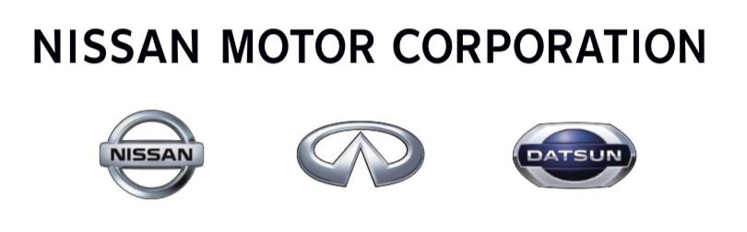Nissan Digital India LLP

APPLICATION FORM –CAR SCHEME FOR SENIOR MANAGERS & MANAGERS

To
The Human Resources Department
Nissan Digital India LLP
Chennai

I have purchased a Nissan car and wish to apply for the eligible allowance, as per the Company’s ‘Car Policy’.

Name | : | Arun S
Employee Code | : | NDH00537
Designation | : | Software Engineering Manager
Department | : | IB4 Connected Mobility, M& S
Date of Joining | : | 24/06/2019

Nissan Car Model & Variant Purchased | : | Nissan Kicks
Car Registration Number | : | KL-01-CP-3020
Month and Year of Purchase | : | 12/03/2020

I have studied in detail the various terms and conditions mentioned in the Car Policy for Managers and above. I hereby offer my unconditional undertaking to abide and be bound by the same.

Date : -----11/06/2021----- Signature: ------------------------------

(Please attach the copy of the signed acceptance letter, a copy of your RC book and valid driving license with this form)
------------------------------------------------------------------------------------------------------------
For HR use only
Date of Start of Allowance | :
Date of end of Allowance | :
Signature of HOD HR | :
Effective month for Change in Allowance in case of promotion | :
Ownership Periodic Verification details | :
Remarks if any | :

